Digital Diagnosis: AI-Based Symptom Analyzer Using ML and Large Language Model
Project report submitted to
Indian Institute of Information Technology, Nagpur,
in partial fulfillment of the requirements for the Mini Project - II
at

DEPARTMENT OF COMPUTER SCIENCE AND ENGINEERING

By

Abhishek Godara[BT23CSA007] Dayanand Swami[BT23CSA016]

Yashwant Chauhan[BT23CSA042]
Under the Supervision of Dr. Milind Penurkar
Session Period: Jan to May 2026


भारतीय सूचना प्रौद्योगिकी संस्थान, नागपुर

INDIAN INSTITUTE OF INFORMATION TECHNOLOGY, NAGPUR
(An Institution of National Importance by Act of Parliament) Survey No.140,141/1 behind Br.Sheshrao
Wankhede Shetkari Sahkari Soot Girni, Nagpur, 441108


Department of Computer Science and Engineering

Indian Institute of Information Technology, Nagpur

Declaration

I/We, Abhishek Godara [BT23CSA007], Dayanand Swami [BT23CSA016], Yashwant Chauhan [BT23CSA042], hereby declare that this project work titled " Digital Diagnosis: AI-Based Symptom Analyzer Using ML And Large Language Model " is carried out by us in the Department of Computer Science and Engineering of Indian Institute of Information Technology, Nagpur. The work is original and has not been submitted earlier whole or in part for the award of any other certification program at this or any other Institution /University.

Date:
Roll no. | Names | Signature
BT23CSA007 | Abhishek Godara
BT23CSA016 | Dayanand Swami
BT23CSA042 | Yashwant Chauhan

Certificate

This is to certify that the project titled “DIGITAL DIAGNOSIS: AI-BASED SYMPTOM ANALYZER USING NLP AND DEEP LEARNING”,
submitted by,
Abhishek Gadara [BT23CSA007], Dayanand Swami [BT23CSA016], Yashwant Chauhan [BT23CSA042], in partial fulfillment of the requirements for the Mini-Project in CSE department IIIT Nagpur. The work is comprehensive, complete and fit for final evaluation.

Date: Dr. Milind Penurkar
Assistant Professor
CSE, IIIT Nagpur

Acknowledgement

It is with immense pleasure that we express our deep sense of gratitude to our supervisor, Dr. Milind Penurkar, for his invaluable assistance, feedback, and encouragement during the course of this project. Without his expertise in machine learning and natural language processing, this project would not have been completed so successfully. Our regular review meetings and his patience while answering all of our queries have enriched our learning process significantly.

We are indebted to the Department of Computer Science and Engineering, IIIT Nagpur, for their help in terms of computational resources and infrastructure. These resources helped us carry out extensive experimentation and train our models efficiently, which played a vital role in completing our objectives.

We appreciate our fellow students for their helpful suggestions and feedback, which contributed significantly to improving the quality of our work.

Finally, we would like to thank the Open Source community and available online resources, which have been instrumental in successfully completing this project. Tools such as Kaggle have been essential in providing computing power for model training purposes, while the Hugging Face website has made available transformer libraries. Similarly, PyTorch documentation has been vital in addressing debugging and optimization problems encountered during implementation.

Abstract
The present report discusses the design of the hybrid agent-based system called Digital Diagnosis that operates as a healthcare triage assistant. Unlike the system that is built based on dropdown symptom checkers and a monolithic deep learning classifier, the novel approach relies on a conversation-driven process that provides an opportunity for a user to discuss his or her concerns freely.
From the architectural perspective, the proposed system features the combination of a conversational agent developed with LangChain and a Groq Llama-3.3-70b model and the use of a deterministic LightGBM classifier based on the dataset including 84 clinical symptoms assigned to 50 specific diseases. In a matter of milliseconds, the classifier provides the top-3 predicted diagnoses and, thereafter, a local knowledge base gives recommendations.
The classification model demonstrates 84.0% top-1 accuracy and 99.0% top-3 accuracy, making it more accurate than any zero-shot LLM-based models and faster than many others.
Keywords: Healthcare AI, Symptom checker, LangChain, LightGBM, Conversation-driven agent, NLP, Hybrid architecture, Disease prediction, Triage assistant.

Table of Contents

Chapter No. | Topic | Page No.
1 | Introduction | 11
1.1 | Motivation | 11
1.2 | Problem Statement | 12
1.3 | Scope and Target Users | 12
2 | Literature Review | 13
3 | Proposed Work | 14
3.1 | Dataset Description | 14
3.2 | System Architecture | 15
3.3 | Workflow | 16
3.4 | Model Development | 17
3.5 | Model Architecture | 17
3.6 | Conversational Agent Design | 17
3.7 | Symptom Parse Design | 17
3.8 | Knowledge | 17
4 | Result and Discussion | 18
5 | Conclusion and Future Work | 26
5.1 | Conclusion | 26
5.2 | Future Work | 26

LIST OF FIGURES
Figure No. |  | Title | Page No.
Figure 3.1 | System Architecture Diagram |  | 15
Figure 3.2 | System Workflow Diagram |  | 16
Figure 4.1 | Confusion Matrix for Top 30 Diseases |  | 19
Figure 4.2 | Frontend - Main Page (Symptom Input UI) |  | 20
Figure 4.3 | Frontend - Result Page Showing Predicted Diseases and Confidence Scores |  | 22
Figure 4.4 | Chatbot |  | 23

List of Tables
Table No. |  | Title | Page No.
Table 3.1 | Dataset Composition and Split |  | 14
Table 4.1 | Overall Model Performance |  | 18
Table 4.2 | ML Model Comparison – Disease Prediction (Top-1 and Top-3 Accuracy) |  | 24
Table 4.3 | LLM Comparison for Symptom Parsing (Precision, Recall, F1) |  | 24
Table 4.4 | LLM Comparison for Disease Prediction (Top-1 and Top-3 Accuracy) |  | 25

List of Abbreviations

Abbreviation | Full Form
AI | Artificial Intelligence
API | Application Programming Interface
LLM | Large Language Model
CPU | Central Processing Unit
CSE | Computer Science and Engineering
F1 | F1 Score (Harmonic Mean of Precision and Recall)
HTML | Hypertext Markup Language
HTTP | Hypertext Transfer Protocol
LightGBM | Light Gradient Boosting Machine
ML | Machine Learning
NLP | Natural Language Processing
RAM | Random Access Memory
REST | Representational State Transfer
UI | User Interface
JSON | JavaScript Object Notation

Chapter-1

Introduction

Getting quick medical concern is not easy for everyone. People check google and pick a symptom from symptom list provided by google, but this tool don't handle natural, everyday description we. They miss the context and not explain the matter very well. Symptom checkers use simple decision trees that can't adapt to how different people explain feeling not well. This problem is specially bad in rural arears because in rural areas may be nearest doctors are hours away from the place.

Our model healthpilot, tackles this by AI to understand how people normally explain their symptom and match these symptoms to possible disease. Instead of force to people select symptoms from list, they are free to type their symptoms. Our project used advanced AI models to catch the nuances and possible combination of symptoms that simpler tools miss. We want :(a) make health guidance easily and correct(b) help people to know that when they really need doctor and (c) give helpful information that point the people in correct direction

1.1 Motivation

Some problems pushed us to build this. First, there is a shortage of healthcare workers worldwide. The WHO said that we are short of 18 million service provider and developing countries condition are worst due to this.

Second, the rapid improvement in LLM capabilities has made it practical to build conversational agents that feel natural. Combining this conversational capability with the accuracy and speed of classical machine learning gives us the best of both worlds: a system that talks like a knowledgeable assistant but makes predictions like a clinical classifier.

What really motivated us was thinking about backward people means rural areas, where less doctor on more people compare to cities. With a good screening tool, we can help people by providing the facility that they urgent care or they handle at the home. This helps the people make better decisions and takes pressure off crowded hospitals by filtering out non-urgent cases.

1.2 Problem Statement

The main issue we're addressing is the disconnect between how patients describe symptoms and getting an accurate disease identification, especially when healthcare access is limited. Traditional diagnosis needs trained doctors who can examine patients and order tests. But millions of people can't get to a doctor quickly. Current online symptom checkers have major flaws - they're too rigid, don't cover enough diseases, can't understand context, and give generic advice that doesn't consider how severe symptoms are or how long they've lasted.

There is also a practical problem with purely LLM-based approaches: they are expensive to run repeatedly, their outputs are non-deterministic, and they cannot be easily audited or explained. Our work builds a system that uses LLMs only where they are genuinely better than alternatives — for understanding natural language — while delegating the classification step to a well-trained, fast, and auditable machine learning model.

1.3 Scope and Target Users
Our project mainly covers building a complete AI system that predicts easily disease from symptoms. We focused on that condition which easily identified by symptom pattern given by users. It's not mean we want to replace a real doctor- it provides an idea to people what to do next.
Our target users are everyday people looking for their health information, telemedicine services that need automatic triage, rural hospital with less workers, and anyone who wants to monitoring their health. It's especially useful when hospital timing is off or holiday. When doctor not meet easily. This project also works as an educational tool, helping people learn about their potential condition and more aware about their health

Chapter 2

Literature Review
Al Shafi Abdullah et al. (2025) created a well-structured disease-symptom dataset aimed at improving the accuracy of disease diagnostics through artificial intelligence. In creating their disease-symptom dataset, the researchers used binary encoding to efficiently encode disease-symptom relationships. In this case, their study sought to collect reliable information from relevant medical sources such as medical literature, databases, and records. Based on their findings, it is crucial to have standardized and multilingual healthcare data sets available, particularly for Bangla medical informatics. They stressed the importance of structuring symptom datasets when dealing with disease prediction, epidemiology, and healthcare artificial intelligence.

In their paper "Digital Diagnostics: The Potential of Large Language Models in Recognizing Symptoms of Common Illnesses," Gupta et al. (2025) explored the performance of different large language models including GPT-4, GPT-4o, Gemini, o1 Preview, and GPT-3 in diagnosing illnesses based on symptoms. Based on their analysis, the researchers concluded that GPT-4 was the best large language model for accurately diagnosing illnesses. On the other hand, Gemini was highly efficient in identifying diseases in risky situations, where accurate reasoning was needed. In this case, the researchers applied symptom prompts sourced from reliable medical literature and measures of precision, recall, and F1-score.

In their paper titled "Optimizing Classification of Diseases Through Language Model Analysis of Symptoms", Hassan et al. (2024) investigated the application of the MCN-BERT and BiLSTM models in automatically predicting diseases based on symptom descriptions. The proposed MCN-BERT model, when optimized using AdamP, scored 99.58% accuracy, proving the efficiency of transformer-based models in medical natural language processing tasks. The research made use of contextualized embeddings and bidirectional learning to better comprehend the intricate relationship between symptoms and diseases compared to conventional machine learning approaches. Hyperopt was used to optimize the model's hyperparameters to improve classification and enhance its generalization ability.

Chapter 3
PROPOSED WORK
3.1 Dataset Description
The training data for the LightGBM classifier originates from a large-scale, real-world clinical dataset containing records for over 50 disease categories sourced from Government website of Columbia . The original dataset contained records spread across 377 distinct symptom labels. We performed a structured feature-engineering step to reduce and consolidate the symptom space, reducing it from 377 to 84 clinically meaningful, unambiguous symptom labels.
covering different manners in which patients can describe the same disease. For instance, a patient with flu may report their symptoms as “feverish and achy” or “high temperature muscle hurt and weak. This variation is essential for learning a model that can deal with real data
Split | Samples | Percentage
Train Set | 2000 | 80%
Test Set | 500 | 20%
Total | 2500 | 100%
Table 3.1: Dataset Composition and split

The unique ID for the remark of each illness was received at consistent labeling. We divided 80/20% of the dataset into train and test set respectively, but to make fair comparison we preserved the same disease distribution in both sets.

3.2 System Architecture

PRESENTATION LAYER
HTML5+CSS3+JavaScript
User Interface

INFRASTRUCTURE LAYER
LightGBM+ Llama-3.3-70b-versatile

Figure 3.1: System Architecture Diagram

Its architecture is based on layers, in which the frontend and back-end services are separated from the machine-learning layer. Users communicate with a reactive frontend in HTML/CSS/JS which sends AJAX requests to the backend server written using FlaskThe Presentation Layer consists of a Streamlit-based chat interface. The Agent Layer is powered by LangChain using Groq-hosted Llama-3.3-70b. The Diagnosis Tool Layer invokes the symptom parser and LightGBM classifier. The Data Layer consists of the serialized LightGBM model and the disease knowledge base.

The tokens are processed by transformer layers in the model that produce probability scores, and the top predictions are chosen. A postprocessor embargoes appropriate medical advice, ranking(s) of severity and specialist advice. These, taken together, ensure a seamless passage from symptom entering to diagnosis.

3.3 Workflow

Step 1: User Input
(User enters their symptoms
Ex. fever, cough, cold….)
Step 2: Intent Evaluation: The LangChain agent determines the user intent.

Step 3: Tool Execution: Once sufficient symptoms are reported, it calls get_diagnosis().
Step 6: Output display
(displays top-3 predicted diseases with their probability and quick solutions)

Step4: Symptom Parsing: The user input is sent to Llama-3.3-70b-versatile, which returns a JSON list of matched symptom labels. An 84-dimensional binary vector is constructed.
Step 5: Select top-3 with advice
(takes top-3 disease from prediction and advice and quick solution from database)

Figure 3.2: System Workflow Diagram

Once the symptoms are entered by the users, the input is checked for its validity and length along with the user’s demographics and sent to the backend server. The backend processes the input, cleans the text data, generates the tokens of up to 128 and feeds them into the machine learning model LightGBM. The output consists of disease probability, top 3 diseases selected and additional medical advice from our database.

3.4 Model Development
The LightGBM classifier was selected after systematic comparison against SVM (RBF kernel) and Random Forest (500 trees). LightGBM outperformed both alternatives on top-1 accuracy and its inference time was under 5 milliseconds per prediction.

3.5 Model Architecture

LightGBM is a gradient boosting framework that grows decision trees leaf-wise rather than depth-wise. In our configuration, 500 decision trees are applied in sequence. The final prediction applies softmax over raw class scores, yielding a 50-dimensional probability distribution over disease categories.
3.6 Conversational Agent Design
The LangChain agent is configured with a system prompt instructing it to behave as a compassionate, clinically informed assistant. The agent uses ConversationBufferMemory to retain the full conversation history. The tool is registered as a LangChain tool with a clear docstring describing when it should be called.

3.7 Symptom Parse Design
The symptom parser is a standalone LLM call using Llama-3.3-70b-versatile via Groq. A key design decision was to use a smaller model (8B parameters) for this task — the symptom parsing task is essentially structured information extraction. The 8B model handles this accurately while costing less per API call and responding faster.
3.8 Knowledge
The knowledge base is a local JSON file containing a structured record for each of the 50 diseases, including: the disease name and UMLS code; associated symptoms; a curated plain-English description; recommended specialist type; severity classification; and first-aid or general care advice.

Chapter-4

Results and Discussion
In this section we provide in-depth evaluation of our final model, which includes total performance as well as training dynamics and qualitative analysis of predictions. The findings show that the Digital Diagnosis system performs well by several evaluation measures and is appropriate for practical deployment as an initial stage screening tool.
Metric | Value
Top1-Accuracy | 0.86
Top3-Accuracy | 0.99
F1 Macro | 0.859
Precision | 0.87
Recall | 0.858
Inference Time | <5 ms

Table 4.1: Overall Model Performance
An 86% top-1 accuracy across 50 disease categories is a strong result. The top-3 accuracy of 99% means that the correct diagnosis appears in the model’s top three suggestions in virtually every case — highly relevant for a triage tool.

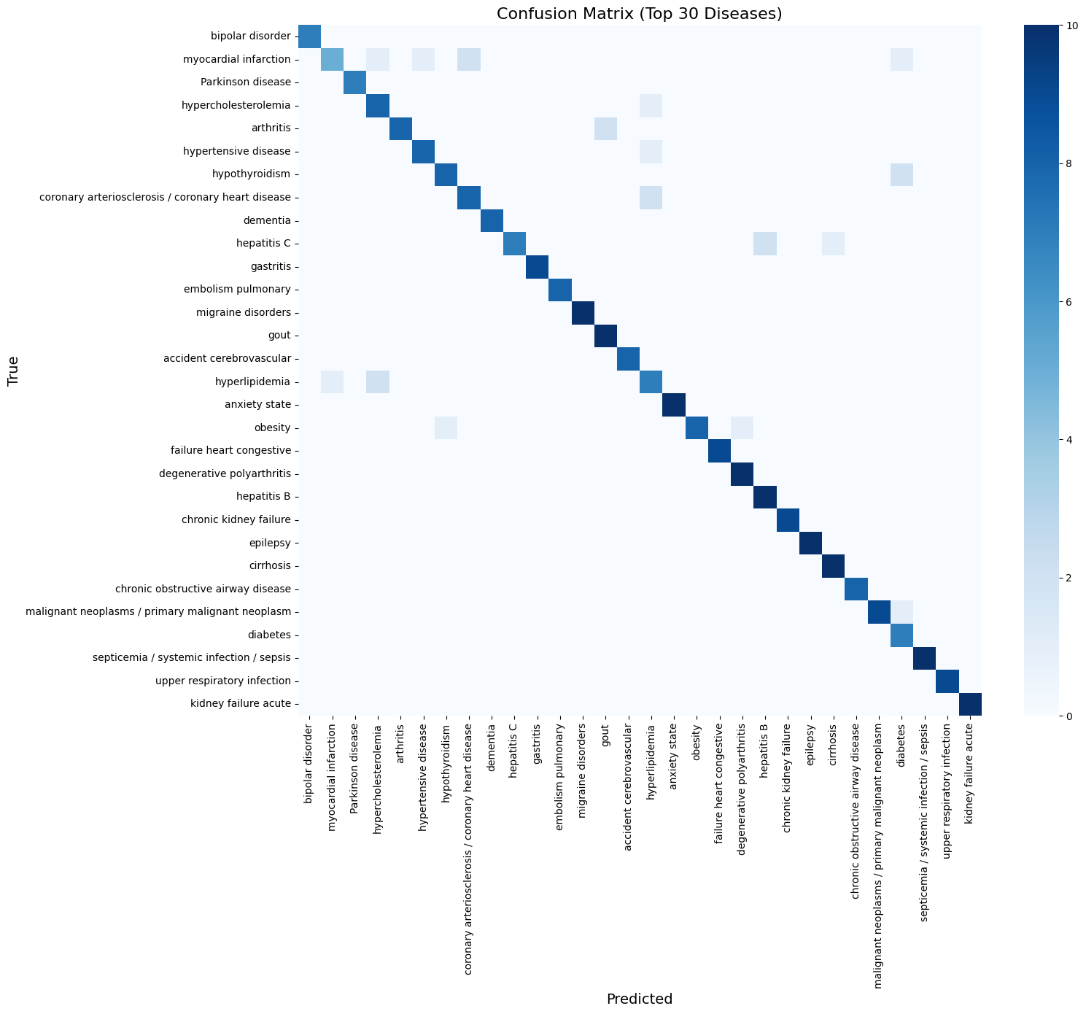
Figure 4.1: Confusion Matrix for Top 30 Diseases
Figure 4.1 shows the confusion matrix of top 30 diseases during prediction on the test data. This intense dark diagonal means our model’s predictions were right. Models The systematic confusion pattern of some OFF- diagonal elements are displayed. For instance our model gets sometimes confused between “acute bronchitis” and “asthma” as most of the symptoms in these diseases are common. Confusion patterns are consistent with medical-related model and this demonstrates the inherent indeterminacy in symptom based diagnosis.

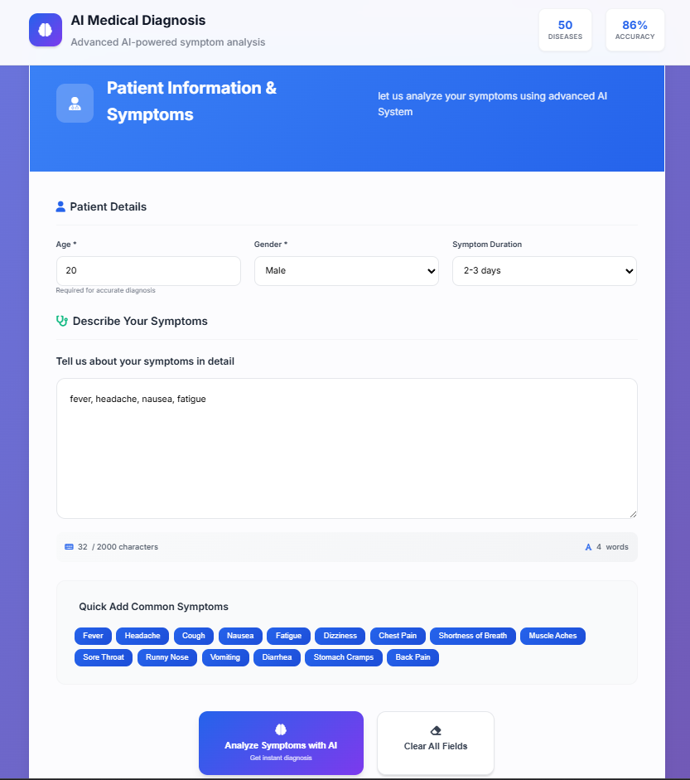
Figure 4.2: Frontend - Main Page (Symptom Input UI)
Figure 4.2 is web page interface of main page of our website(HealthPilot) where a user has to mention symptoms, their age, their gender, symptom duration. The simplicity is too much that each and every one can understand and there is no confusion. Users can simply type their symptoms or use quick-add button to mention common symptoms.
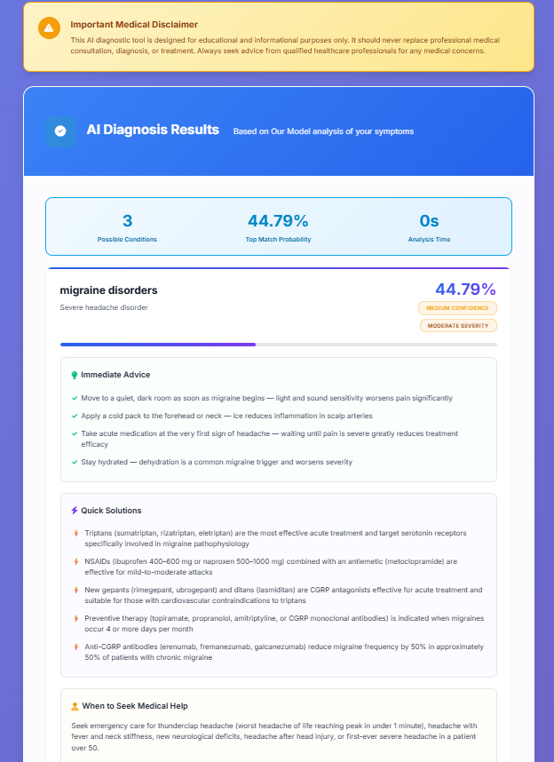
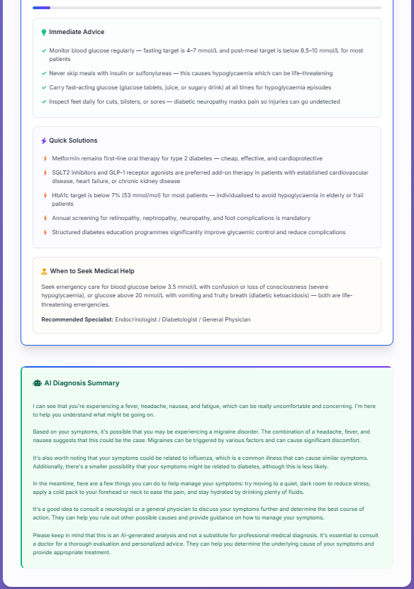
Figure 4.3: Frontend - Result Page Showing Predicted Diseases and Confidence Scores

The results interface is presented in Figure 4.3 where we show user top-3 diseases with their symptoms along with the confidence value of our model on that disease. And we also offer users instant advice and quick solutions. If a prediction \(>80%\) sure, then it already gives an extra warning. we also suggest user to consult from any specialist or we also recomandate him specialist.

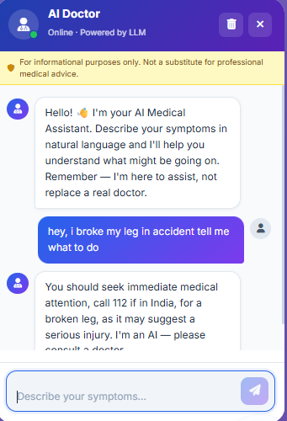

Figure 4.4: Chatbot

The Figure 4.4 is an illustration of the main user interface of our application. With the help of the chatbot driven by LangChain, one can interact freely with the system and share their feelings; the system will then automatically identify the symptoms and provide a diagnosis and user can also talk about their problems to chatbot.

Model | Top1-Accuracy | Top-3Accuracy
SVM | 75% | 90%
Random Forest | 78% | 94%
LightGBM | 84% | 99%

Table 4.2: ML Model Comparison – Disease Prediction (Top-1 and Top-3 Accuracy)
LightGBM achieves the highest top-1 accuracy (84.0%) and best top-3 accuracy (99.0%), outperforming SVM (75.0% / 90.0%) and Random Forest (78.0% / 94.0%).

Model | Precision | Recall | F1
llama-3.1-8b-instant | 0.9333 | 0.8754 | 0.9034
llama-3.3-70b-versatile * | 0.9667 | 0.9334 | 0.9498
Llama-4-Scout-17B (Meta) | 0.96 | 0.8144 | 0.8812
gpt-oss-safeguard-20b | 0.9433 | 0.90 | 0.9211
gpt-oss-120b | 0.9367 | 0.8932 | 0.9144
Table 4.3: LLM Comparison for Symptom Parsing (Precision, Recall, F1)

The llama-3.3-70b-versatile model achieves the best F1 (0.9498) among models evaluated.

Model | Top1-Accuracy | Top3-Accuracy
LightGBM – Ours(Hybrid) | 84% | 99%
llama-3.1-8b-instant | 76.0% | 92.0%
llama-3.3-70b-versatile * | 84.0% | 96.0%
Llama-4-Scout-17B (Meta) | 76.0% | 95%
gpt-oss-safeguard-20b | 80.0% | 94%
gpt-oss-120b | 76.0% | 89.0%

Table 4.4: LLM Comparison for Disease Prediction (Top-1 and Top-3 Accuracy)

Chapter-5

Conclusion and Future Work

5.1 Conclusion
Digital Diagnosis demonstrates that a thoughtfully designed hybrid system outperforms both pure deep learning and pure LLM-based approaches for practical healthcare triage. By separating the problem into natural language understanding (handled by LLMs) and medical classification (handled by LightGBM), we achieve a system that is simultaneously conversational, fast, reproducible, and accurate.
The LightGBM classifier achieves 84.0% top-1 accuracy and 99.0% top-3 accuracy across 50 disease categories, outperforming SVM and Random Forest baselines. The comparative evaluation across five LLMs confirms the architectural premise: no single LLM achieves a better combination of accuracy, speed, and determinism than the hybrid approach for the classification step.

5.2 Future Work
Some potential avenues for improving and extending Digital Diagnosis v2 include:
- Increasing the disease ontology: The current model accounts for 50 diseases. Expanding the number to 150+, especially rare diseases, will increase the applicability of the system.
- Improving the symptom parser recall: Tuning a small model specifically to perform on a symptom extraction task will probably yield improvements in recall.
- Multilinguality: Translating the model's response into different languages or using a multilingual model would dramatically increase the accessibility of the system across India’s diverse language environment.
- Severity scoring and urgency detection: Having a numerical urgency scoring system would increase the accuracy of triage recommendations.
- Speech recognition: Adding a speech-to-text module (via Whisper) would make the system available to a much wider audience.
- EHR data ingestion: Using an existing EHR database would enable the agent to consider the user's medical history during its diagnosis and recommendations.
- Validation via clinical trials: Comparing system recommendations to those of physicians based on a prospective clinical trial would generate the necessary data.

The broader goal is to establish this hybrid agentic architecture as a reusable pattern for healthcare AI systems that other developers can adapt to address different clinical domains.

References
[1] Hassan, E., Abd El-Hafeez, T., & Shams, M. Y. (2024). Optimizing classification of diseases through language model analysis of symptoms. Scientific Reports, 14, 1507.

[2] Devlin, J., Chang, M. W., Lee, K., & Toutanova, K. (2019). BERT: Pre-training of deep bidirectional transformers for language understanding. Proceedings of NAACL-HLT 2019, 4171–4186.

[3] Lee, J., et al. (2020). BioBERT: A pre-trained biomedical language representation model for biomedical text mining. Bioinformatics, 36(4), 1234–1240.

[4] Alsentzer, E., et al. (2019). Publicly available clinical BERT embeddings. arXiv:1904.03323
.
[5] Vaswani, A., et al. (2017). Attention is all you need. Advances in Neural Information Processing Systems, 30, 5998–6008.

[6] Rasmy, L., et al. (2021). Med-BERT: pretrained contextualized embeddings on large-scale structured EHRs for disease prediction. npj Digital Medicine, 4(1), 86.

[7] Ke, G., et al. (2017). LightGBM: A highly efficient gradient boosting decision tree. Advances in Neural Information Processing Systems, 30, 3146–3154.

[8] Chase, H. (2022). LangChain: Building applications with LLMs through composability. GitHub.

[9] Omoregbe, N. A. I., et al. (2020). Text messaging-based medical diagnosis using NLP and fuzzy logic. Journal of Healthcare Engineering, 2020, e8839524.

[10] Hammoud, M., et al. (2024). Evaluating the diagnostic performance of symptom checkers: Clinical vignette study. JMIR AI, 3, e46875.

[11] Harada, Y., et al. (2024). Longitudinal changes in diagnostic accuracy of an AI-based symptom checker. JMIR Formative Research, 8, e53985.

[12] Koleck, T. A., et al. (2019). Natural language processing of symptoms documented in free-text narratives of EHRs: A systematic review. JAMIA, 26(4), 364–379.

[13] Wolf, T., et al. (2020). Transformers: State-of-the-art natural language processing. Proceedings of EMNLP 2020: System Demonstrations, 38–45.

[14] Semigran, H. L., et al. (2015). Evaluation of symptom checkers for self diagnosis and triage: Audit study. BMJ, 351, h3480.

[15] Dataset: https://people.dbmi.columbia.edu/~friedma/Projects/DiseaseSymptomKB/index.html

[16] Groq API Documentation. https://console.groq.com/docs/overview

[17] Streamlit Documentation. https://docs.streamlit.io

